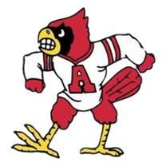**Alton High School**

**Afternoon at the Ballpark**

**Sunday, MAY 21st @ 1:15**

[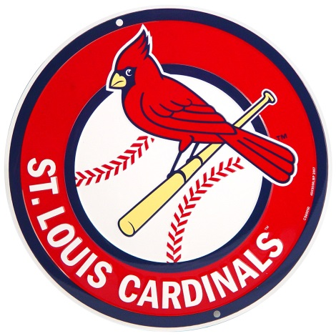](https://www.google.com/url?sa=i&rct=j&q=&esrc=s&source=images&cd=&cad=rja&uact=8&ved=2ahUKEwiB2sTwwaPaAhUSbawKHdF8CZkQjRx6BAgAEAU&url=https://www.retroplanet.com/PROD/25104.html&psig=AOvVaw3xzpblfzCQqfwpJtuI8WjN&ust=1523030737915553) **vs.** 

**$35 Ticket ($68 Face Value)**

Lower RF Box Sections (100 level)

Giveaway: 16 & older:  Cardinals Golf Umbrella (first 25,000)

Prairie Farms Ice Cream “Sundays”

*Business Sponsorship Opportunities Available!*

See any AHS baseball player to purchase tickets

Contact: Scott Harper—[sharper@altonschools.org](mailto:sharper@altonschools.org) or 618.474.2253

Alton HS Athletic Office 618.474.1800